Ideation Phase

Define the Problem Statements

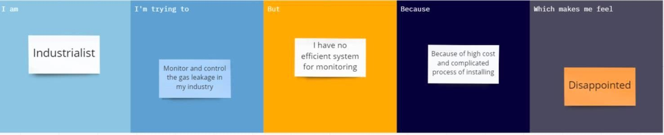

|  |  |  |  |  |  |
| --- | --- | --- | --- | --- | --- |
| **Problem Statement**  **(PS)** | **I am (Customer)** | **I am trying to** | **But** | **Because** | **Which makes**  **mefeel** |
| PS-1 | Industrialist | Monitor gas leakage in the  industry | I don’t have anysystem for monitoring | The affordable of the systemis high and the systems are sometimes  making disasters | Unsafe |